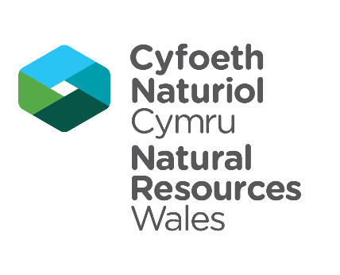

NRW Application Form – Student Work Experience Placement
This form is available in Welsh and English

Role applied for

Placement title

Personal details

Full name
Date of Birth
E-mail address
Telephone number
Address

Name of school
(if in full or part time education)
Address of school/college/university

If Home Educated give details of programmes of study /courses currently being studied

Communication

As a bilingual organisation we use both Welsh and English in our work.

What is your preferred language for communicating with us? | Choose an item.  Click or tap here to enter text.

Experience
In this section you can tell us about your relevant experience, including paid employment and voluntary work. Please list these with the most recent first. You may leave this section blank if you have not yet completed any.

Date from | Date to | Name of employer | Brief description of experience
Click or tap to enter a date. | Click or tap to enter a date.

Qualifications

In this section you can tell us about your relevant qualifications. Please include the most recent first. Include qualifications that you are currently studying.

Date | Qualification | Education provider | Level
Click or tap to enter a date.

Personal statement

Please answer the following questions to tell us more about yourself. Your answers will help us if we have lots of applications for the role.

Tell us about yourself and the interests you have, including any skills or experiences that would be relevant to the role (word limit 250)

Why would you like to complete work experience at NRW? (word limit 250)

Disability
Natural Resources Wales operates a “two ticks” guaranteed interview scheme for anyone with a disability as defined in the Equality Act 2010. The Act defines a disabled person as someone who has a mental or physical impairment that has a substantial and long term adverse effect on the person’s ability to carry out a normal day to day activities.

If you confirm that you have a disability, and we consider that you meet the minimum criteria for the placement, you will be guaranteed an invite to interview.
Please tick to confirm if you consider yourself to have a disability as defined above and want to apply under the guaranteed interview scheme. ☐

Declaration

I declare that the information I have given is to the best of my knowledge and belief true and complete.
Signature (print your name)
Date | Click or tap to enter a date.

Retention of information

The information on this form will be held and used by Natural Resources Wales in accordance with the provisions of the General Data Protection Regulation and all relevant subsequent legislation. If you have any further queries or concerns, please contact Dataprotection@naturalresourceswales.gov.uk

For further information on the processing of your personal details please see the Privacy Notice page on our website.

Submitting your application
Thank you for your interest in Natural Resources Wales.
Please send your completed Application Form and Equalities Monitoring Form to Placements@naturalresourceswales.gov.uk by the closing date, using the placement number as a reference.
Successful applicants will be contacted by the placement manager to discuss what happens next. This could be an email, phone call or an invitation to an informal interview. If you are unsuccessful we will also let you know and explain why.

Further information

For further information about the placement, please contact the Placement Manager.

